**REFERENCE WEBSITES –**

1. [myassignmenthelp.com](http://myassignmenthelp.com/)
2. [myassignmenthelp.co.uk](http://myassignmenthelp.co.uk/)

**This is the requirement of the website.**

As Discussed,

The Template of the website will be like this website- <http://demo.featherlayers.com/edupro-general-1/>

The Pattern of the website is as per- Myassignmenthelp.com

The website's top most Slab (Header) will be containing a logo and link to pages-

1. Logo

2. Services

3. Experts

4. Reviews

5. Login

6. Order now

(This Tab would be constant and it would be there in the entire website)

Along with the lower most Slab (Footer) of the website.

The Website's last Slab Containing-

1. Get to know us-

2. Let us help

3. Contact us etc.

(This Tab would be constant and it would be there in the entire website)

*The Website's pages would be changing between these 2 Slabs at the top most and the bottom.*

The list of pages and details-

1. **Home page-**  (World Home Page) – 1 Page

There would be total 1 homepage as of now which will later on be replicated to create country based home pages.

**~ Header Details ~**

1. **Services** (Assignment category) - 10 Pages

This will be a drop down link which will display around 10 different category and subcategories and will be link to the pages later. Take reference of the reference website for clear understanding.

1. **Reviews-** 1 Page

Review by different people that will be like a card layout in which on click will display a modal with their particular reviews. (Take reference from the reference website provided)

1. **Order -** 2 Page

It will take user to a page in which it will first let user fill basic

Details and after that will take to the second page for descriptive data fill up. It

Can be a 2 page approach or like a toggle approach. (Will be communicated

Later).

1. **Get to know us-**  4 Pages

It will be a title which will be subtitled with different pages.

For reference look into the footer of the website https://myassignmenthelp.com/

Pages will be –

a) About us

b) How it works

c) Jobs

1. **Let us help you-** 7 Pages

It will be a title which will be subtitled with different pages.

For reference look into the footer of the website https://myassignmenthelp.com/

Pages will be –

a) My Account

b) FAQs

c) Resources

d) Premium

e) Privacy Policy

f) Terms of use

g) Revision and Refund policy

1. **Contact Us-**

It will be just an information kind of slot with different links and address of contact. For further reference look into the footer of the website <https://myassignmenthelp.com>

**Attachment 1.**

**Kindly, find the Home Page's Wire frame as an attachment excel along with this document file.**



**Now here is the Footer pages content and images that will be used for each individual pages.**

**Note: -** The images not be a background page, it will be like a banner on top of page and then content will be below that banner with black text font and white background.

**Attachment 2.**

|  |  |  |
| --- | --- | --- |
| **Page Name** | **Content** | **Banner Image** |
| **LOGO** | **Not Required** |  |
| **Home Page** |  |  |
| **- Let Us help you -** | | |
| 1. **My Account** | **Not Provided** | **Not Provided** |
| 1. **FAQ** |  |  |
| 1. **Resources** | **Not Provided** |  |
| 1. **Premium** |  |  |
| 1. **Privacy Policy** |  | **Not Provided** |
| 1. **Terms of Use** |  | **Not Provided** |
| 1. **Revision and Refund Policy** |  | **Not Provided** |
| **- Get to know Us –** | | |
| 1. **About Us** |  |  |
| 1. **How it Works** |  |  |
| 1. **Jobs** |  |  |

**First Release/Deliverable Requirement:-**

As per our discussion,

Below are the sections planned for the first release:-

**World Home Page:**

1. Content
2. Mini Order Form (That will redirect to SIGN UP/SIGN IN and save the data to database)

***Field in Mini Order form:-***

* Email id
* Subject
* Deadline
* No of words

1. Callback Request Button

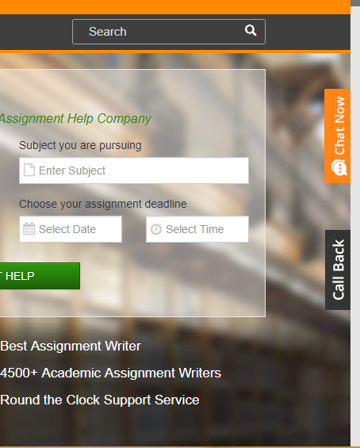 It will be a pop up that will come out after clicking on a hanging button attached to right side of screen, which is basically a from that user will fill to get a scheduled call from company about his request. Like below image-

***Field in Call Back pop up form:-***

* Name
* Phone
* Email
* Time zone
* Preferable time

1. User Home Page

It will contain the same header and footer but on place on

Sign In / Sign Up button,

* It will be a Logout button A

And in body

* Welcome Username –
* A Table which will contain the Order placed by user in a tabular form.

**Note: -** Use the best tabular representation possible with different effects.

1. Order page

Basic order page with a form and upload document feature which will trigger a mail to us and save data to the database.

***Field in Order Page form:-***

* Name
* Email
* Phone
* Subject
* Deadline date and time
* Time zone
* Comments/description
* Attach file

1. Sign in

Basic Sign in Page with a Form, a Login button and Sign up now button. We are not working on password reset option it will just have a popup triggering a mail to us and we ll reset the password manually and send it to registered mail id. Data will be stored and retrieved from database.

1. Sign Up

  Basic Sign up page with form and Create button and Cancel button.

***Field in Sign Up form:-***

* Name
* Country
* Specialization
* DOB
* Username
* Password

**Total Pages:** - 5 (For First Delivery and Demo)

The content of remaining pages will be provided as we go ahead, content for the homepage is already provided for starting up.

The sitemap will be provided once the individual pages are completed.

Please let us know your thoughts on the plan and expected timeline so that we can freeze the requirements.